EXP:2
CODE:
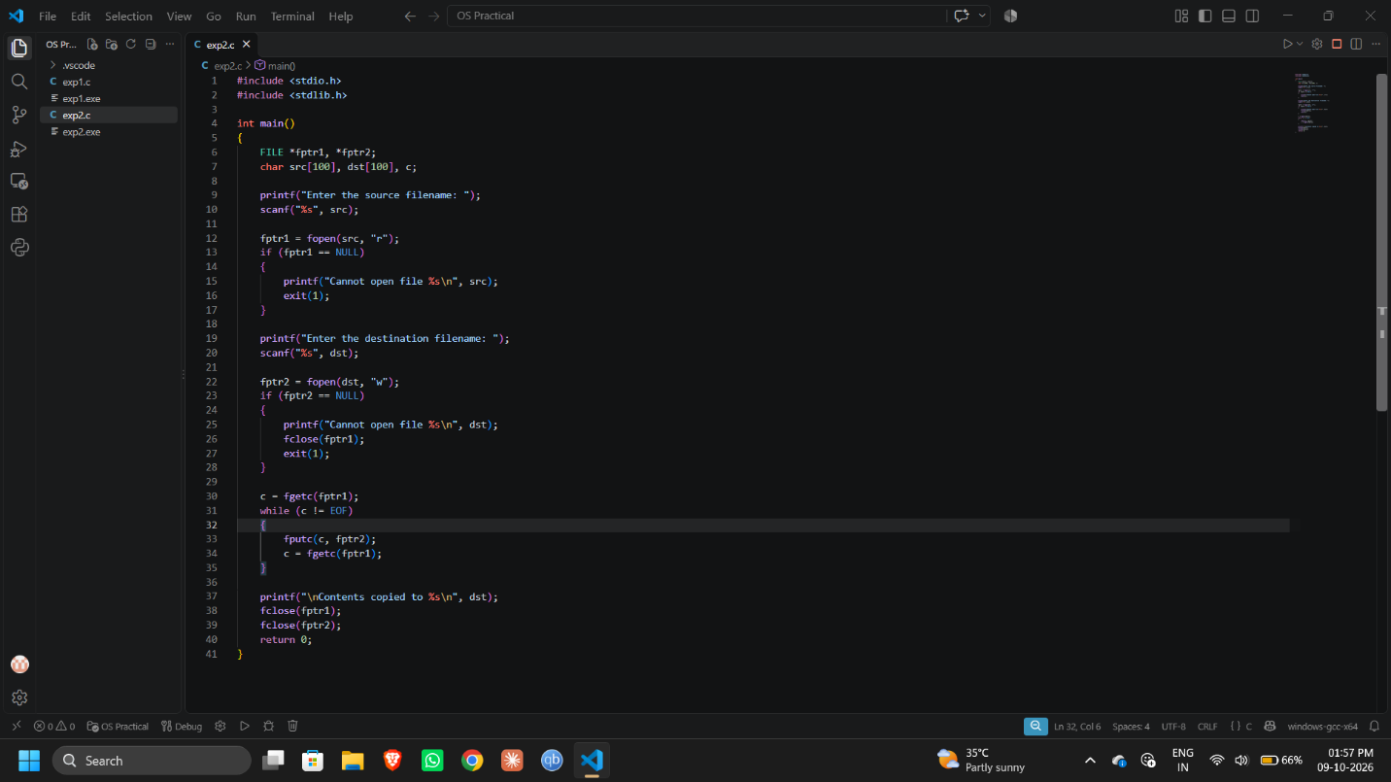
OUTPUT:
